SELECT s.name as "Nombre de la Canción",

s.popularity as "Popularidad de la Canción",

ar.name as "Nombre del artista"

FROM songs as s

INNER JOIN artists as ar

ON ar.id = ANY(s.id_artists1)

WHERE s.popularity >= 0.0

ORDER BY "Popularidad de la Canción" desc;

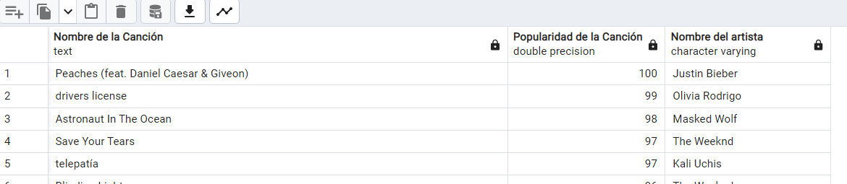

SELECT s.name as "Nombre de la Canción",

s.popularity as "Popularidad de la Canción",

ar.genres as "Género del artista"

FROM songs as s

INNER JOIN artists as ar

ON ar.id = ANY(s.id_artists1)

WHERE s.popularity = (SELECT MAX(popularity) FROM songs);

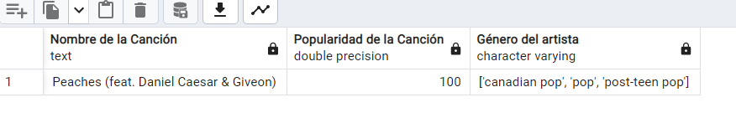

SELECT s.name as "Nombre de la Canción",

s.popularity as "Popularidad de la Canción",

ar.followers as "Seguidores del artista"

FROM songs as s

INNER JOIN artists as ar

ON ar.id = ANY(s.id_artists1)

WHERE ar.followers = (SELECT MAX(followers) FROM artists);

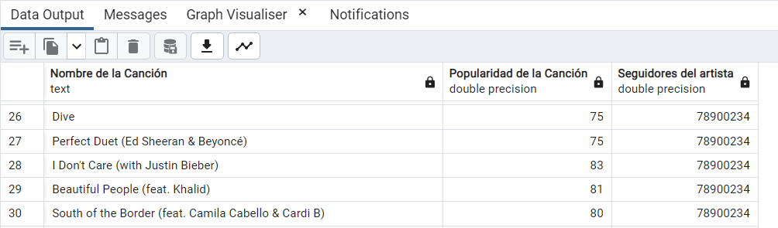

BIG QUERY

